# horizontal lineDatabase

Project part 4

I confirm that this is my own work and that use of material from other sources, including the Internet, has been properly and fully acknowledged and referenced.

|  |  |
| --- | --- |
| Name: | Pang, Jinhao |
| Date: | 2022.12.22 |
| NYU ID: | N19475049 |
| Course Section Number: | csci-ga.2433-001 |



**Total in points** (100 points total): _____

**Professor’s Comments:**

|  |
| --- |
|  |

**1. Business Use Cases**

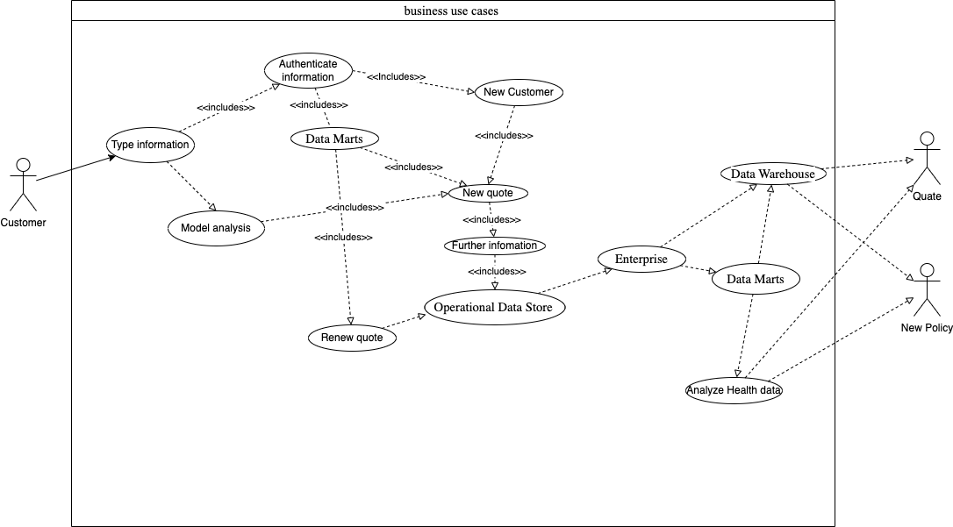

Figure 1 Business use case

The idea is that the customer types related health information into the system and systems respond with quotes and policy by analysis. The program gives an example of kidney disease. Health records can be input to analyze the possibility of kidney disease, then insurance companies can use this to modify the insurance quotes and policies.

**2. Model**

The kidney model is trained on Google Colab, the related database design and connectivity framework is in the appendix of the Colab file.

The link is <https://colab.research.google.com/drive/1V2qRofrjW-T4PQMghpGN5y9E6y757C3L?usp=sharing>

**3. End-to-End application**

There is a simple display of the kidney predication model, which is written by Flask.

The source code is in the delivery zip file and there is a link to the demo website.

The link is <http://34.125.160.71:5000/>

**4. Reference architecture documentation**

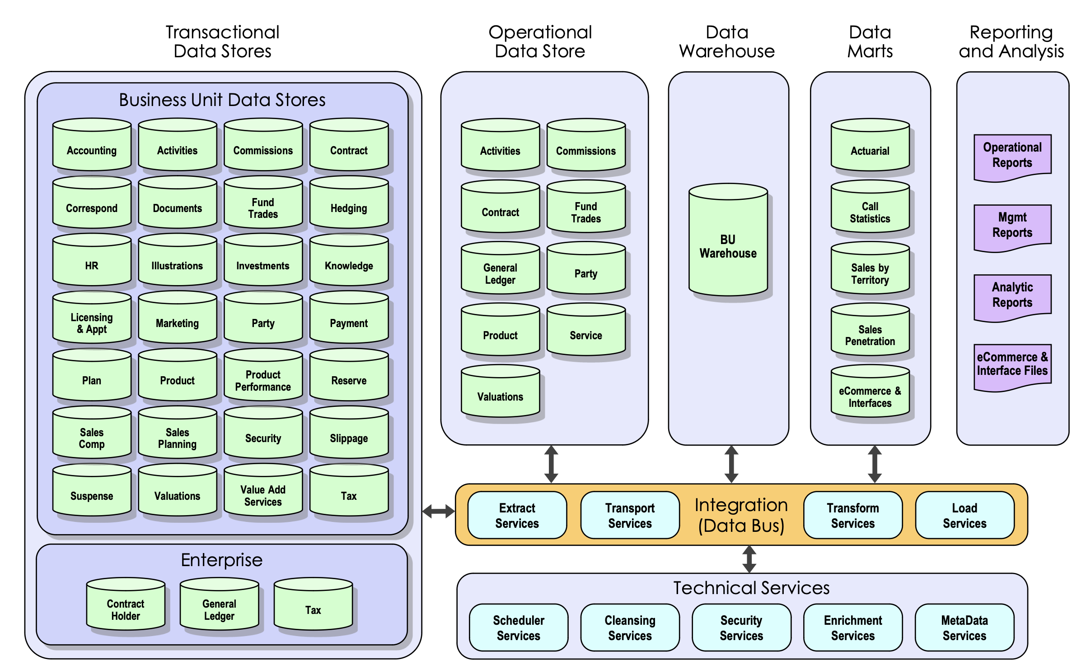

Figure 2 Reference architecture from Slices

Similar to the reference architecture in the slice, we use all of the parts mentioned above. Transactional data stores include all the business data used in the applications and systems for contracts and transactions. Compared to the slices, the difference is reporting and analysis is used for the insurance company instead of customers. Staff uses these data to modify the policies and quotes, while customers can only see the given policy without reasoning.